**4. Cronjob:**

Task: Create a shell script which will take backup of any Text file on daily 11:30 AM and paste into the /backup folder.

**Step -1. Create the shell script:**

Save the script with a descriptive name (backup.sh)

**nk**

#!/bin/bash

# Set the path to the text file you want to back up

text_file_path="/home/aditya/Documents/Spiderverse"

# Set the backup directory

backup_dir="/home/aditya/Documents"

# Create the backup directory if it doesn't exist

mkdir -p "$backup_dir"

# Get the current date and time in a format suitable for filenames

timestamp=$(date +"%Y%m%d_%H%M%S")

# Construct the backup filename

backup_filename="$backup_dir/$timestamp.txt"

# Copy the text file to the backup directory with the generated filename

cp "$text_file_path" "$backup_filename"

**Step -2. Make the script executable:**

In your terminal, navigate to the directory where you saved the script. Run chmod +x backup.sh to grant execution permissions.

**Step -3. Schedule the script using cron:**

Open the crontab editor with the command “crontab -e”.

Add the cron job: Paste the following line, replacing the placeholder with the actual path to the script.

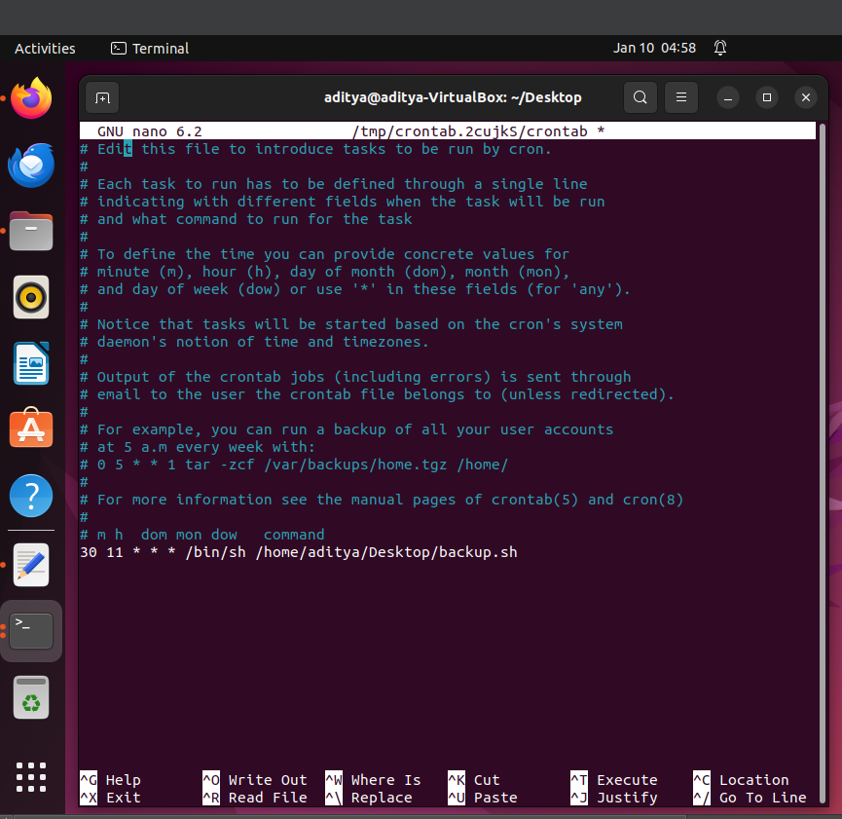

Save the crontab file: If using Nano, press Ctrl+X, then y, and Enter. If using Vim, press Esc, then type :wq and Enter.

**Step -4. Test the script:**

Run the script manually using /path/to/your/backup.sh to ensure it works as expected. Check for backups in the /backup directory.